THE DA VINCI CODE

This book, written by Dan Brown, is currently the worldwide best-seller (May 6, 2006).

Comment on the Name of the Author
Before I begin speaking about our topic I would like to tell you a little amusing tidbit about the author’s name. When Jacob the patriarch wished to bless his sons, the twelve tribes of Israel, “Jacob called his sons and said, Gather together, that I may tell you what shall befall you in the last days.” He took all the tribes beginning from Reuben, Simeon, Levi, Judah, until he reached Dan, and said, “Dan shall judge his people as one of the tribes of Israel. Dan shall be a serpent by the way, a viper by the path, that bites the horse’s heels so that its rider shall fall backward. I have waited for your salvation, O LORD!”
Truly Dan Brown has bitten all those who love Christ, to the extent that many readers of this book said that Satan must have been dictating to him. Others suffered from despondency and depression for several days after reading this book —it is as a gloomy cloud darkening the mind.
I do not recommend that anyone reads the book, or watches the movie. It is replete with innumerable lies, therefore, books were published to counter it:
The Da Vinci Hoax
The Truth Behind The Da Vinci Code: A Challenging Response To The Best-Selling Novel
The Da Vinci Code: A Response
The Da Vinci Deception.
They are not referring to Leonardo Da Vinci the artist of the Mona Liza, but to this book written by Dan Brown.
Also, some videos came out in response. One such video is called The Da Vinci Code Deception. This was filmed in America, and featured many great scientists and theologians, along with video clips of locations, documents, and events. Anyone seeing this documentary realizes that The Da Vinci Code is nothing more than a collection of lies and fabrications, despite the fact that the start of the book clearly states: “Fact: All descriptions of artwork, architecture, documents, and secret rituals in this novel are accurate.” What stirs ridicule is that nothing written in this book is accurate! Even geography, history, setting, or vicinity –all are lies. Satan is known as “a liar and the father of it,” and when he lies, he says, ‘I tell the truth, the whole truth’; Dan Brown imitated his tutor’s approach.
Certainly we will not be able to cover the entire issue of The Da Vinci Code here; but to remedy what we could, we will give a brief summary of the issue.

Was Mary Magdalene the Holy Chalice? Was she Christ’s Wife?
This is mere nonsense!
In fact, The Da Vinci Code relies on a Gnostic gospel, The Gospel of Philip, where there is a phrase which Dan Brown personally supplemented to an incomplete sentence. By this he arrived at, that Christ kissed Mary Magdalene on the ‘lips’, meanwhile, the gospel of Philip itself does not contain this detail. He took an incomplete line, where the papyrus has deteriorated, and added his own words, and believed his own lie. This is the first point.
The second point is that he wrote plainly in his book, that:
“Jesus suspects that He will soon be captured and crucified, so He gives Mary Magdalene instructions on how to carry on His church after He is gone.”
What is this nonsense?
He was crucified, died, and commissioned Mary Magdalene to carry the holy seed.. She went to France, stayed in Lyon, and brought forth the royal bloodline to France!
He not only made it that Jesus married Mary Magdalene, but he went much further that she is the one who carries the church.

The Shekinah
Dan Brown claims in this same book that God personally was married. How? He claims that inside the Holy of Holies, in Solomon’s Temple, they find “Shekinah”. For Jews, Shekinah is a Hebrew word that means ‘Jehovah dwells,’ in other words ‘God dwells in His house.’ Therefore the Psalm says, “But as for me, I will come into Your house in the multitude of Your mercy; In fear of You I will worship toward Your holy temple.”
Now, what does Dan Brown say? He says that Jehovah was married to Shekinah. Has anyone ever heard that God, the God of Israel, was married to Shekinah inside the Temple of Solomon? Who would accept such nonsense? The God of Israel was married to a female called Shekinah to whom He entered inside the Holy of Holies in the temple. Have you seen to what extent his insolence has reached: that the heavenly Father is married! This is unacceptable by Jews, Christians, and Muslims..
Therefore, he finds it easy to say that Christ was married..

YHWH
Another catastrophe: he says that the Jewish Tetragrammaton, YHWH, that is the four letter Hebrew word that constitutes the personal name of Yeheweh meaning the existent. Now, Dan Brown says that the word is taken from the word Jehovah which is composed of two parts, the masculine prefix, Jah or Yah, (it is well known that Yah is a part of the name Yeheweh and in the Book of Isaiah it is written: “Behold, God is my salvation, I will trust and not be afraid; For, YAH the LORD, is my strength and song; He also has become my salvation,”) and the suffix, Havah, meaning Eve. Therefore, he says that the very name YHWH is composed of two syllables, one masculine and one feminine, because God was married to a Goddess. Perhaps he is insinuating Eve.
If God the Father is married, then when Christ the Son marries, then He is moving along the same lines. The Son incarnated, but the Father did not incarnate!

Mormons:
These concepts exist among the Mormons. They say that God the Father was a human, married, gave birth to Jesus, Satan, and others, then became a God, and Jesus is the son of this God. These are all absurdities which we reject as Christians. We also reject any claims that God the Father married.
Furthermore, we do not consider Mormons as Christians. They are in in Salt Lake City, USA have Utah University, and are the founders of the Marriott Hotels worldwide. This is a different subject that would need a separate article.

Priory of Sion:
In the Da Vinci Code, its author writes that there is a sect called the Priory of Sion which was established in 1099 AD by the King of France. If you search for this Priory of Sion (Zion), you find that in fact, it was established in 1956 AD. Now, why twist history?
Dan Brown claims that there are documents found at the French Museum, which claim that Leonardo Da Vinci, Isaac Newton, and other renowned historical personalities were the grand masters of the Priory of Sion. These are similar to the Massonians who have secret prayers, who allegedly know the secret of the Holy Grail, the blood Chalice, Mary Magdalene who bore the blood of Christ because she carried His child (Bite his tongue!).
We look to find that the documents he is referring to are two pieces of paper placed in the French Museum. In researching, the following was found: the founder of the Priory of Sion is a man named of Pierre Plantard. This Pierre Plantard is the one who fabricated these documents and planted them in the French Museum, on which Dan Brown bases his claim that Leonardo Da Vinci was the grand master of this sect. Of course Leonardo Da Vinci lived in the Middle Ages and has nothing to do with this, neither did he attend the Priory of Sion, or additionally be its grand master. This is fabricated fabrication.
The author further claims that in the Rosslyn Chapel in Scotland is the Solomon seal, the star of David, placed on the ground in a specific location. When they were capturing the movie, they visited the Rosslyn Chapel, and raised the carpeting at the indicated location to reveal that there is no such star on the ground.
Furthermore, Dan Brown claims that the ones who built this chapel were the Knights Templar, who were prepared by the Priory of Sion for the Crusades.
He fused the Crusades with Leonardo Da Vinci the artist and the Priory of Sion; he claims it was founded in 1099 while it was actually founded in 1956 by an anti-Semite, Pierre Plantard.

The Portrait of the Last Supper:
The author further claims that at portrait of the Last Supper painted by Lionardo Da Vinci, we find that the one sitting next to Christ, is Mary Magdalene.
Now, when we examine the portrait of the Last Supper (first of all, this is not during the Last Supper, but actually during the Jewish Passover, as there is not one cup and bread, but several cups) we find that those seated at the table are twelve. We find Judas clinging onto the money-bag (he is the only one whose face is blackened), Peter is holding a knife behind his back while asking John to ask Christ who will betray Him.

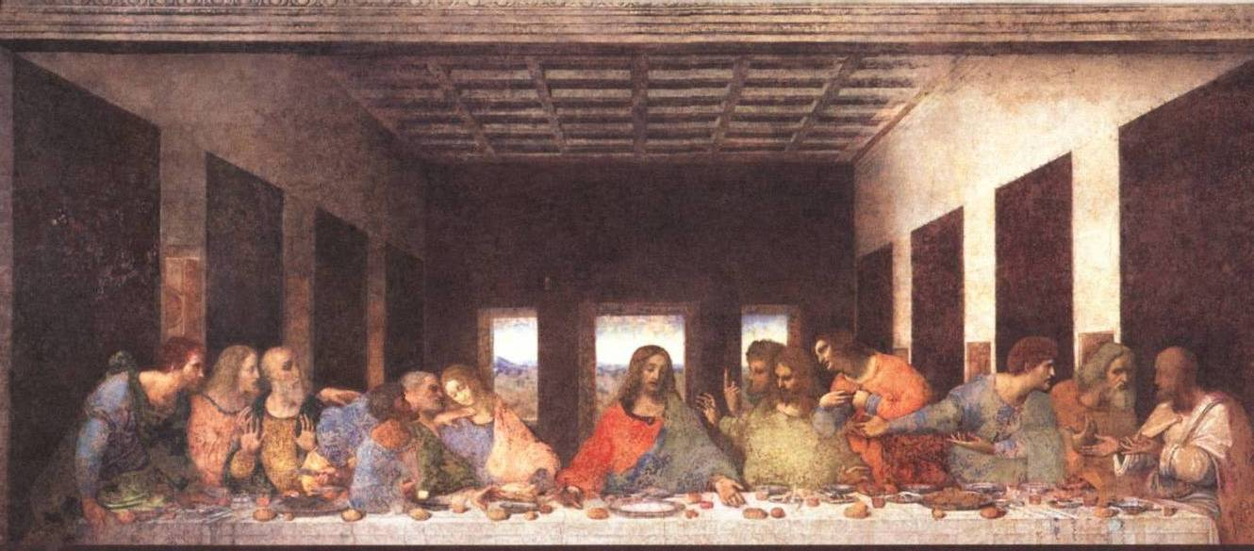

There are three beardless persons, John and two other disciples. Because John was young and had no beard, Dan Brown claims that this is Mary Magdalene sitting next to Christ, and yet, at inspecting the painting you would find a distance between John’s hands and Christ’s hands and between Christ and John, because at that time Peter was speaking to John.

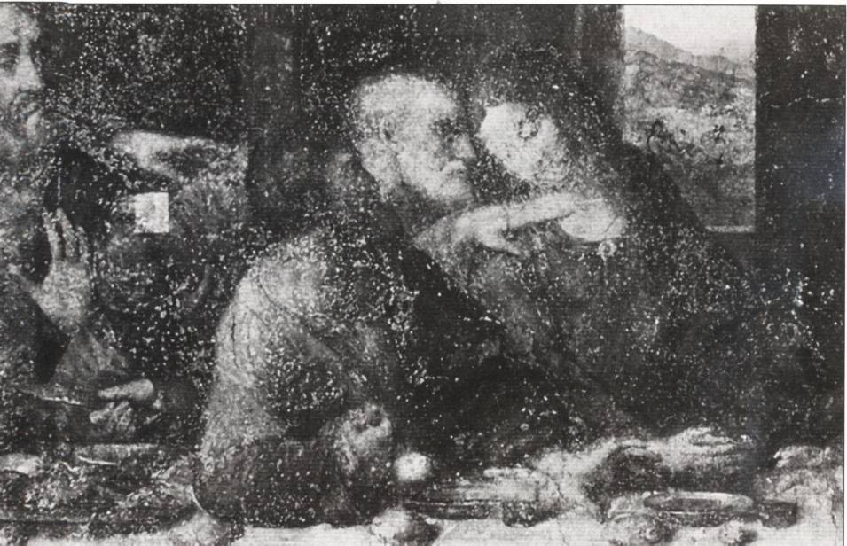

Leonardo Da Vinci put the threesome together: Judas with his blackened face holding the money with one hand while the other is grasping in fear because he is terrified while Peter is telling John to ask Jesus who will betray Him, Peter is grasping the knife with his other hand, behind his back and John. Leonardo grouped the three together: the disciple who was at the cross, the impetuous disciple who denied Him, and the treacherous disciple. These three had an obvious role in the final events of the Life of our Lord on earth.
There is not one cup, but many, therefore this was the Jewish Passover, after which Judas left, and thereafter Christ offered the Lord’s Supper.

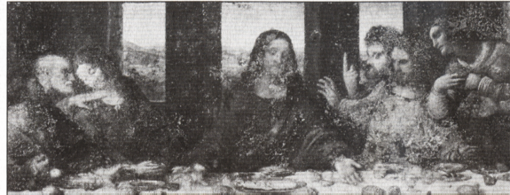

Dan Brown claims that this ‘V’ shape (the space between Christ and John) is the Holy Grail, the one of which He said, “For this is My blood of the new covenant, which is shed for many for the remission of sins.” Can anyone claim that Christ would say about the empty air that it is His blood? What is this fabrication!

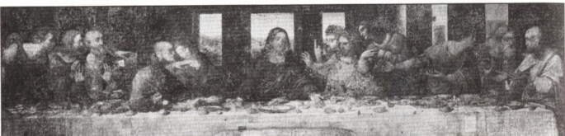

Count the disciples, you will find twelve, and Judas is present. If Mary Magdalene were present they would have been thirteen.
If Judas was not present and they were twelve we would have wondered who the twelfth person was, but they are only twelve. These are diabolic thoughts.

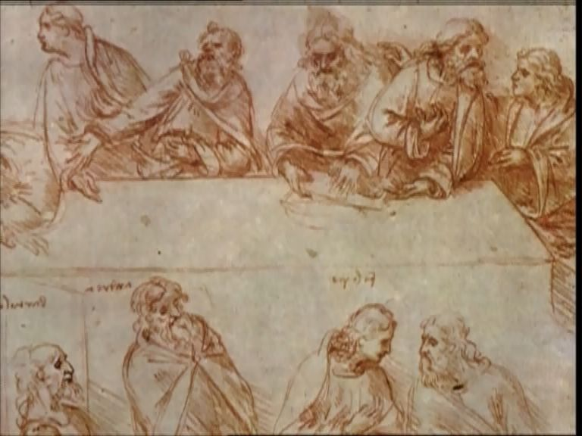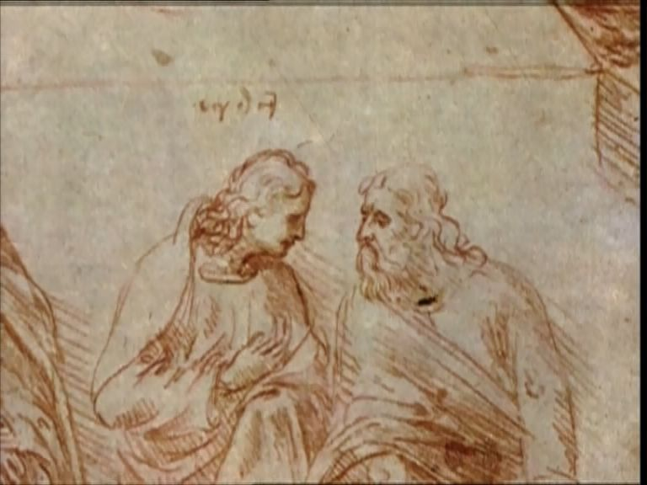

Furthermore, Leonardo Da Vinci is an artist from the fifteenth century, who painted a portrait for the Last Supper. He neither attended the Last Supper, nor seen anything. And yet, when we return to the sketches he made, we find that he made sketches of the twelve apostles, writing each ones name over his head. John is beardless, and his name is written over his head.

Conclusion:
The Da Vinci Code is nothing more than mere fiction. The film begins with a murder incident in France and the investigation eventually unearthed that they had killed the person who was the secret-keeper, the grand master of the Priory of Sion, the last one who knew the secret, and so the Catholic Church wanted to eliminate him so that no one would know that Christ gave conception to Mary Magdalene.
Is this a book that deserves to shake the world this way?
I am truly sad over the condition of the world!!
If people disdained this book, no one paying any attention to it, then this writer would have been ashamed. Especially since in a television interview he stated that at first he was researching this issue in order to refute this idea, but after much research he believed. This is a tactical strategy on his part, to give the situation a dramatic plot.

Gen 49:1
Gen 49:16-18
Jn 8:44
Ps 5:7
Is 12:2
Mk 14:24

